Go to local vm
- Create a directory
Mkdir dir1 dir2 dir3
- Create some files
Touch file1 file2 file3
Create snapshot
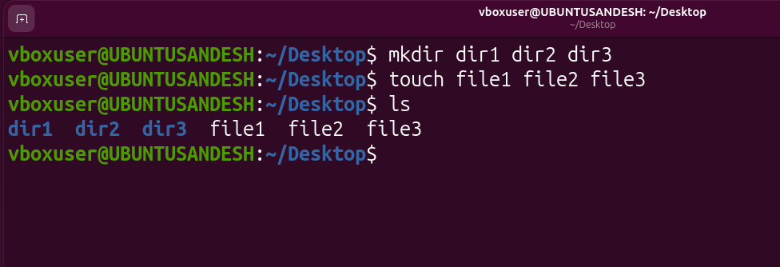
Take snapshot
- Click take
- Insert Snapshot name and description
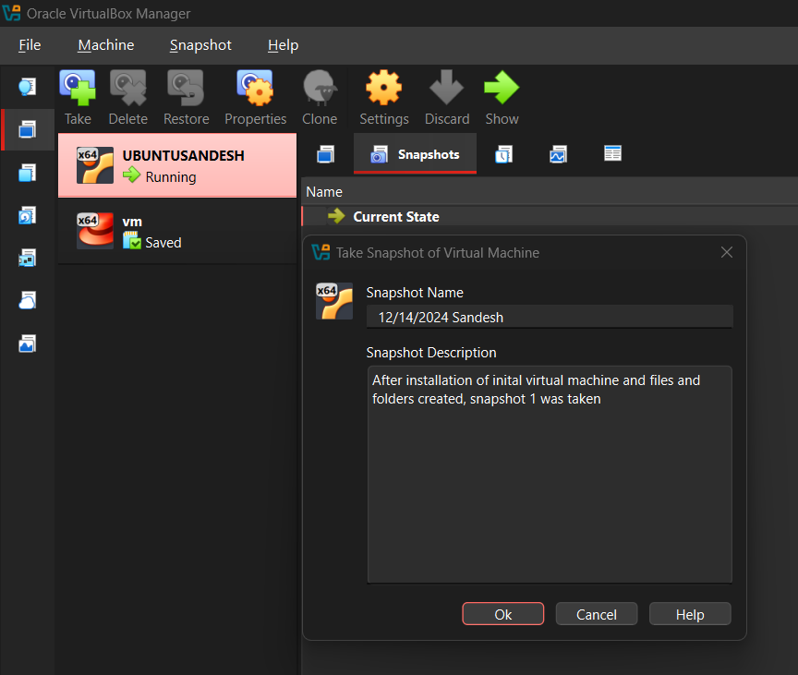
Snapshot done:
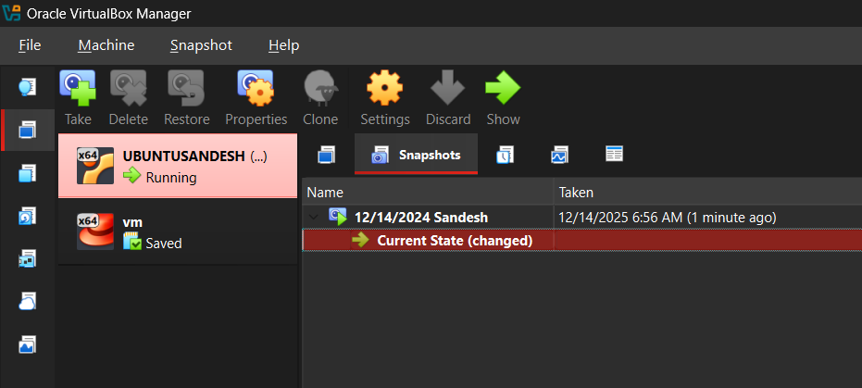
Delete all files from ubuntu:
- rm -rf *
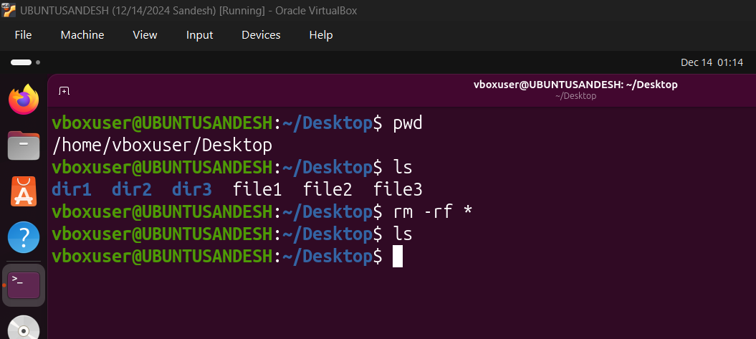

Power off the machine
Sudo poweroff
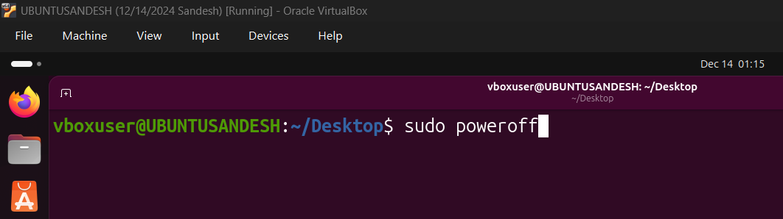

Restore:
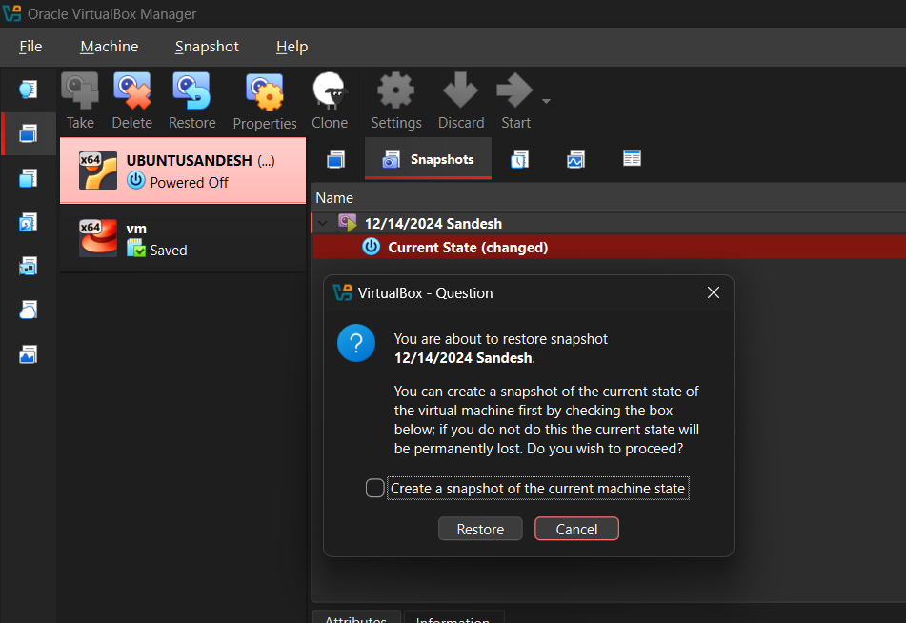
Restore current snapshot
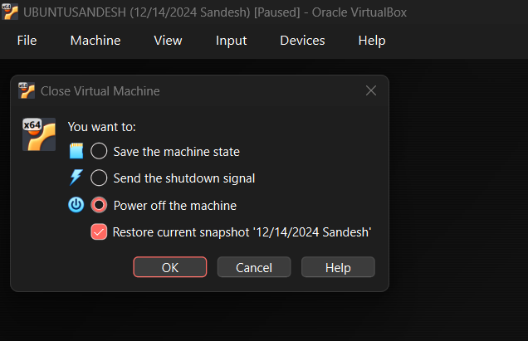

Restored file validation
